Payroll Management System for Information Technology Company

For Subsystem or Feature

Version 1.0

Revision History

|  |  |  |  |
| --- | --- | --- | --- |
| **Date** | **Version** | **Description** | **Author** |
| 06/11/2019 | 1.0 |  | Quản Trọng Tú |
|  |  |  |  |
|  |  |  |  |
|  |  |  |  |

Table of Contents

1. Introduction 4

1.1 Purpose 4

1.2 Scope 4

1.3 Definitions, Acronyms, and Abbreviations 4

1.4 Overview 4

2. Overall Description 4

2.1 Use-Case Model Survey 5

2.2 Assumptions and Dependencies 5

3. Specific Requirements 5

3.1 Use-Case Reports 6

3.2 Supplementary Requirements 6

# Introduction

The introduction of the **Software Requirements Specification (SRS)** provides an overview of the entire document. It includes the purpose, scope, definitions, acronyms, abbreviations, references, and overview of the **SRS**.

The Payroll Management System at IT company is Software Requirements Specification. Instead of managing salaries through the use of papers and some common documents that lead to confusion and errors, administrators and accountants can use this application to pay salaries for employees correctly.

## Purpose

Specify the purpose of this **Software Requirements Specification**. The **SRS** fully describes the external behavior of the payroll management system at IT company. It also describes nonfunctional requirements, design constraints, and other factors necessary to provide a complete and comprehensive description of the requirements for the software. The Supplementary Specification captures the complete software requirements for the system, or a portion of the system. Requirements described in this document are derived from the Vision Document prepared for the Payroll Management System.

## Scope

The Supplementary Specification captures all the requirements in a single document. The Payroll management system that is to be developed provides the administrator, accountant and the employees of the IT company.

## Definitions, Acronyms, and Abbreviations

* SRS: software requirements specification
* Entities: a definable thing or concept within a system

## Overview

The Software Requirements Specification captures all the requirements in a single document. The Payroll Management System that is to be developed provides the administrator, accountant and the employees of the IT company with user profile, Salary and many other function.

# Overall Description

This section of the **Software Requirements Specification** describes the general factors that affect the product and its requirements. This section does not state specific requirements. Instead, it provides a background for those requirements, which are defined in detail in Section 3, and makes them easier to understand. Include such items as product perspective, product functions, user characteristics, constraints, assumptions and dependencies, and requirements subsets.

## Use-Case Model Survey

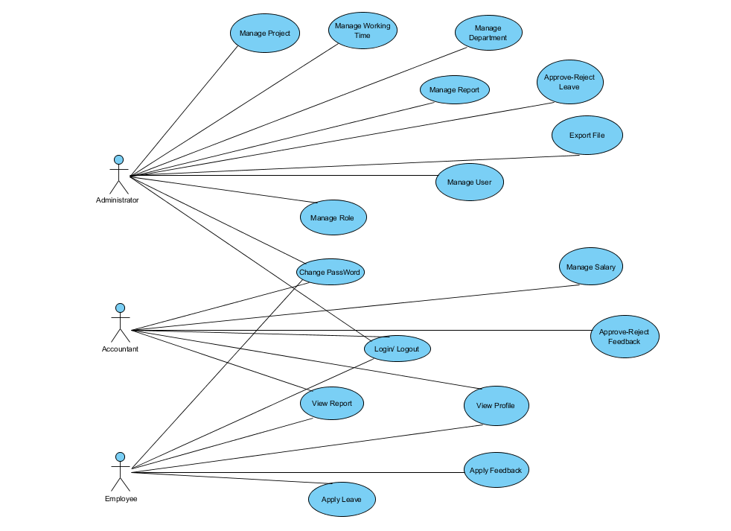

* Administrator: is responsible for managing the employees and playing an important role in manage factor that effect to employee’s salary.
* Accountant: is responsible for calculating and confirm salary for employee.
* Employee: is allowed to feed back and view about own salary.

## Assumptions and Dependencies

|  |  |
| --- | --- |
| Assumptions | Dependencies |
| The users have sufficient knowledge of computer | Build up this system professionally |
| The user knows English language | The interface of application will be provided in English language |
| MySQL is running on Computer | Application runs on Window or other Operation |

# Specific Requirements

* Administrator: is responsible for managing the employees and playing an important role in manage factor that effect to employee’s salary.
* Accountant: is responsible for calculating and confirm salary for employee.
* Employee: is allowed to feed back and view about own salary.

## Use-Case Reports

This will be reported in Use-Cases Specification documents.

## Supplementary Requirements

* Since this a tool which can be used from anytime in the world, so the server should be well managed for such kind of requirement.
* In case, human resource management system was destroyed, the administrator can manage the Human resource through this tool.